|  |
| --- |
| **Installing replication software** |

1 Configuration file 2

1.1 Create folders 2

1.1 Create Configuration File 2

1.1.1 Ship Settings 3

1.1.2 Managed Devices 3

1.1.3 Authentication 3

1.1.4 Connections 3

1.1.5 Managed Interfaces 3

2 Comm-E / Manual installation 4

2.1 Configuration Comm-E 4

2.1.1 Jobs 4

2.1.1.1 Iris DataSource Files 4

2.1.1.2 Iris Log Files 4

2.1.1.3 Errors 4

2.2 Manual Configuration 5

2.2.1 Jobs 5

2.2.1.1 Iris DataSource Files 5

2.2.1.2 Logs 5

3 Server Installation 5

4 Client Installation 5

5 Create ticket for SA/SE 5

# Configuration file

## Create folders

Base folder of configuration files: \\jdn-file01\iris\PRD

Create the following subfolders with the 4-digit code of the site as the name of the folder:

* \\jdn-file01\iris\PRD\DataSources\<xxxx>
* \\jdn-file01\Iris\PRD\Logs\<xxxx>

Replace "xxxx" with the code of the site in Comm-E.

## Create Configuration File

Create a file with name "SiteConfiguration.xml" in the "DataSources\<xxxx>" folder. It is best to start from an existing configuration file. You can find the template and the software at the following location.

[\\jdn-file02\software$\Software - JDN DotNet Development\Other\Iris\<latest version>](\\\\jdn-file02\\software$\\Software - JDN DotNet Development\\Other\\Iris\\<latest version>)

The configuration file has 3 sections. Example:

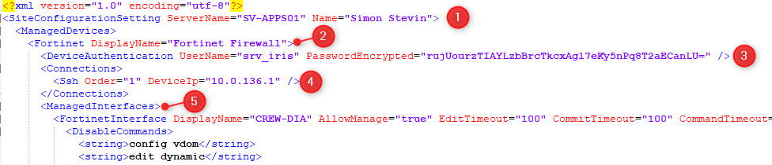

### Ship Settings

Fill in the following properties:

* ServerName: the name of the server on which to install the Iris Service. This must be the short name of the server without domain.
* Name: Informative name of the ship.

### Managed Devices

This section in the configuration file contains all the settings for manageable devices. Fill in a user-friendly display name, to display to the user.

### Authentication

This section contains the authentication settings of the device. Fill in the username (srv_iris) and password. Create this account on the firewall if it does not exist already.

Encrypt the password generated for the account using the "Jdn.Iris.EncryptionHelper" tool. You can find it in the following folder:

[\\jdn-file02\software$\Software - JDN DotNet Development\Other\Iris\<latest version>\Jdn.Iris.EncryptionHelper](\\\\jdn-file02\\software$\\Software - JDN DotNet Development\\Other\\Iris\\)

### Connections

This section contains the different connections used by Iris to connect to a device. Currently only SSH connections are supported. For SSH connections the device ip address is a required parameter.

### Managed Interfaces

This section contains all the physical network interfaces available on the device of for which the user may see the state. Fill in the following properties for each interface:

* DisplayName: a user-friendly name for the port, to display to the user.
* AllowManage: a setting that defines if the user can manage the interface. Enabling this means that the user will be able to enable or disable the specified network interface.

# Comm-E / Manual installation

## Configuration Comm-E

Attach the template "Iris" to the site to enable Iris to work with Comm-E.

### Jobs

#### Iris DataSource Files

This job runs from the head office to the remote site and sends the configuration file(s) to the site.

This job only runs on demand.

#### Iris Log Files

This job runs from the remote site to the head office and sends the local log files to the head office.

This job runs daily.

#### Errors

If errors occur on a remote site, the Application Monitoring jobs will replicate the data. You can see the errors in the application monitoring software or you can set it up to receive email alerts using the application.

## Manual Configuration

### Jobs

#### Iris DataSource Files

It is possible to let IRIS work directly, if you copy the site Configuration file into the Datasources on the ship.

E:\APPLICATIONDATA\IRIS\DataSources

If folder after installation of IRIS does not exist, you have to create it.

#### Logs

You do not have to copy anything here.

If folder does not exist after installation of the Host, you have to create it.

# Server Installation

To install the server component, simply install "Jdn.Iris.**Host**.Setup.msi".

Fill in the parameter containing the work drive. (E:)

Install this on the XX-APPS01 on the new standards.

# Client Installation

To install the client component, simply install "Jdn.Iris.**Management**.Setup.msi".

Fill in the parameter containing the server name (XX-APPS01).

Install this on the Captain's VM and on the MGMT VM

# ~~Create ticket for SA/SE~~

~~Create a ticket for SA/SE to put the firewall back in sync in Junos Space.~~

* No longer required for Fortinet? To be checked with SA/SE.